# 20210924
# There were two naigos check, that were not worked on Ubuntu 20.04 LTS.
# 20210915 Переустановка ОС на сервере ds-asterisk12 - Ubuntu 20.04
# Ubuntu was installed from previously prepaired iso-image, that was made via ci/cd in Kurbanov's repository.
#

#
# Nagios configuration.
#
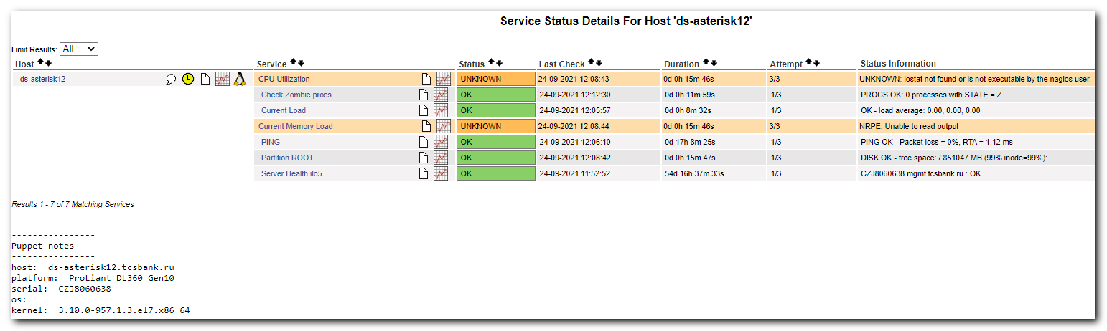

# To fix the first check.
root@ds-asterisk12:~# grep -ire "check_cpu" /etc/nagios
/etc/nagios/nrpe.cfg:#command[check_cpu_stats]=/usr/lib/nagios/plugins/check_cpu_stats.sh $ARG1$
/etc/nagios/nrpe.d/check_cpu_stats.cfg:command[check_cpu_stats]=/usr/lib/nagios/plugins/check_cpu_stats.sh
/etc/nagios/nrpe.d/check_cpu_stats.cfg:command[check_cpu]=/usr/lib/nagios/plugins/check_cpu_stats.sh
root@ds-asterisk12:~# /usr/lib/nagios/plugins/check_cpu_stats.sh
UNKNOWN: iostat not found or is not executable by the nagios user.
root@ds-asterisk12:~#

root@ds-asterisk12:~# apt install sysstat

root@ds-asterisk12:~# /usr/lib/nagios/plugins/check_cpu_stats.sh
CPU STATISTICS OK : user=0.00% system=0.02% iowait=0.00% idle=99.98% nice=0.00% steal=0.00% | CpuUser=0.00;CpuSystem=0.02;CpuIoWait=0.00;CpuIdle=99.98;CpuNice=0.00;CpuSteal=0.00;30;100
root@ds-asterisk12:~#

# Fixing the second check.
root@ds-asterisk12:~# grep -ire "check_memory_load_linux" /etc/nagios
/etc/nagios/nrpe.d/check_memory.cfg:command[check_memory_load_linux]=/usr/lib/nagios/plugins/check_mem_linux.pl -f -C -w 15 -c 5
/etc/nagios/nrpe.d/check_memory.cfg:command[check_memory_load_linux_args]=/usr/lib/nagios/plugins/check_mem_linux.pl -f -C $ARG1$
root@ds-asterisk12:~# /usr/lib/nagios/plugins/check_mem_linux.pl -f -C -w 15 -c 5
Can't locate Getopt/Std.pm in @INC (you may need to install the Getopt::Std module) (@INC contains: /etc/perl /usr/local/lib/x86_64-linux-gnu/perl/5.30.0 /usr/local/share/perl/5.30.0 /usr/lib/x86_64-linux-gnu/perl5/5.30 /usr/share/perl5 /usr/lib/x86_64-linux-gnu/perl/5.30 /usr/share/perl/5.30 /usr/local/lib/site_perl /usr/lib/x86_64-linux-gnu/perl-base) at /usr/lib/nagios/plugins/check_mem_linux.pl line 26.
BEGIN failed--compilation aborted at /usr/lib/nagios/plugins/check_mem_linux.pl line 26.
root@ds-asterisk12:~#

root@ds-asterisk12:~# apt install perl
Reading package lists... Done
Building dependency tree
Reading state information... Done
The following additional packages will be installed:
libgdbm-compat4 libperl5.30 perl-base perl-modules-5.30
Suggested packages:
perl-doc libterm-readline-gnu-perl | libterm-readline-perl-perl make libb-debug-perl liblocale-codes-perl
The following NEW packages will be installed:
libgdbm-compat4 libperl5.30 perl perl-modules-5.30
The following packages will be upgraded:
perl-base
1 upgraded, 4 newly installed, 0 to remove and 134 not upgraded.
Need to get 8,433 kB of archives.
After this operation, 46.2 MB of additional disk space will be used.
Do you want to continue? [Y/n] Y
Get:1 http://repo-linux.tcsbank.ru/repository/ubuntu focal-updates/main amd64 perl-base amd64 5.30.0-9ubuntu0.2 [1,513 kB]
Get:2 http://repo-linux.tcsbank.ru/repository/ubuntu focal-updates/main amd64 perl-modules-5.30 all 5.30.0-9ubuntu0.2 [2,738 kB]
Get:3 http://repo-linux.tcsbank.ru/repository/ubuntu focal/main amd64 libgdbm-compat4 amd64 1.18.1-5 [6,244 B]
Get:4 http://repo-linux.tcsbank.ru/repository/ubuntu focal-updates/main amd64 libperl5.30 amd64 5.30.0-9ubuntu0.2 [3,952 kB]
Get:5 http://repo-linux.tcsbank.ru/repository/ubuntu focal-updates/main amd64 perl amd64 5.30.0-9ubuntu0.2 [224 kB]
Fetched 8,433 kB in 2s (4,033 kB/s)
...
Setting up perl-modules-5.30 (5.30.0-9ubuntu0.2) ...
Setting up libgdbm-compat4:amd64 (1.18.1-5) ...
Setting up libperl5.30:amd64 (5.30.0-9ubuntu0.2) ...
Setting up perl (5.30.0-9ubuntu0.2) ...
Processing triggers for man-db (2.9.1-1) ...
Processing triggers for libc-bin (2.31-0ubuntu9) ...
root@ds-asterisk12:~#

root@ds-asterisk12:~# /usr/lib/nagios/plugins/check_mem_linux.pl -f -C -w 15 -c 5
OK - 99.2% (196141196 kB) free.|TOTAL=197743128KB;;;; USED=1601932KB;;;; FREE=196141196KB;;;; CACHES=923212KB;;;;
root@ds-asterisk12:~#

